Electric Fields Simulator Lab

This lab uses the Electric Field Hockey and Charges and Fields simulations from PhET Interactive Simulations at University of Colorado Boulder, under the CC-BY 4.0 license.
https://phet.colorado.edu/sims/cheerpj/electric-hockey/latest/electric-hockey.html
https://phet.colorado.edu/sims/html/charges-and-fields/latest/charges-and-fields_en.html

Learning Goals: Students will be able to
- Determine the variables that affect how charged bodies interact
- Predict how charged bodies will interact
- Describe the strength and direction of the electric field around a charged body.
- Use free-body diagrams and vector addition to help explain the interactions.
- Compare electric fields to gravitational fields.

Explain your understanding:
Answer all questions using complete sentences. Your answers are to be evidence of your own work with the simulators.
Make a copy of this Google Doc and fill in your work. Note that the questions marked with a * are particularly important...this work will be evaluated in detail.

1. Open the Electric Field Hockey simulation. Try to make a goal by using a positive charge and then with a negative charge like below:
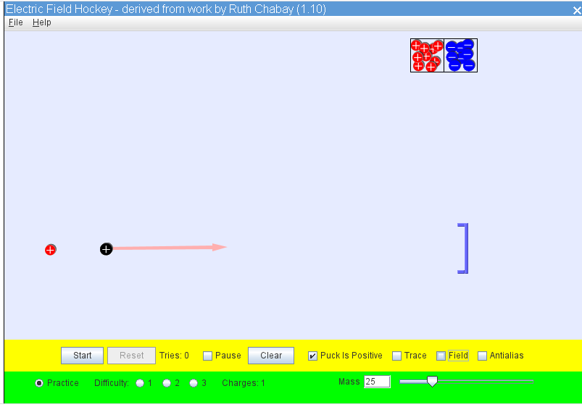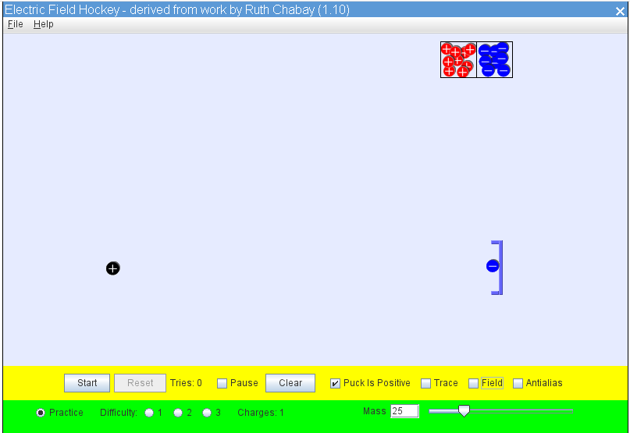
- Why can you make a goal without hitting the puck like in a real hockey game?

- Why can you use either a positive charge or a negative charge to move the positively charged puck?

- What do you think would happen if you use 2 charges instead of one to make the puck move?

- Play with the simulation to check your ideas about moving a charged puck with other charges. Test your ideas by playing the game and describe how you used the charges to make a goal on Level 1. Include a screen image of your setup with the puck in the goal.

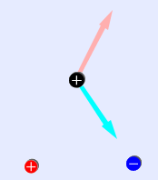
2. Examine the image with a positive and a negative charge on the playing field with the positive puck.
- What do you think the arrows on the puck are illustrating?

- How does the arrow from the positive charge compare and contrast to the one from the negative charge?

- Which way do you think the puck will move?

- How would the arrows look if the puck was negative?

- Check your ideas using Electric Field Hockey.

- What is the difference between the Field lines around a charge and the arrows coming out of the puck?

- Think about how you can use the field lines to predict the motion of the puck if the arrows were hidden. Test your ideas by playing the game and describe how you used the charges to make a goal on Level 2. Include a screen image of your setup with the puck in the goal.

3. Open Charges and Fields. In this simulation, a little different model is used. The little yellow “E field sensors” are like the hockey puck but they are on a high friction surface, so they stay in place allowing for measurements. Collect data by turning on Values & drag in the Tape Measure like in this image:
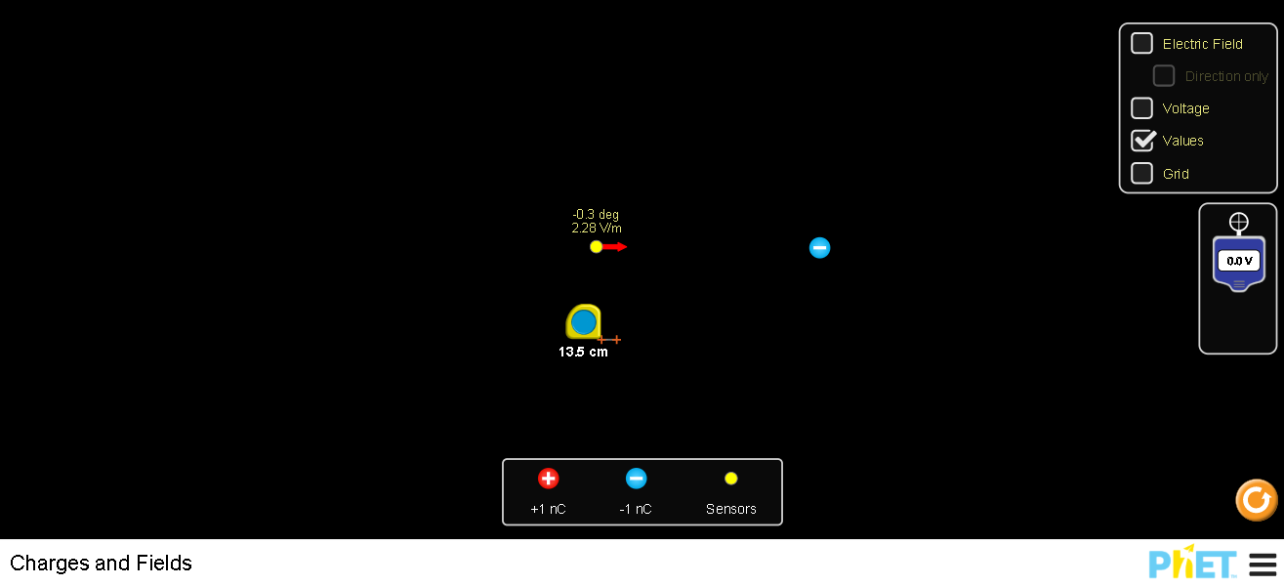
- Investigate (use the simulator) to check your answers from #1 and #2. Explain how the results of your investigation support or change your ideas.

- * Determine the relationship between distance and the strength of the electric field (V/m is equivalent to N/C) around a charged body. Use a Google Spreadsheet to document your data, graph and determine the equation for the relationship. Insert your data table and graph from your spreadsheet. Include your equation.

- * Determine the relationship between amount of charge and the strength of the electric field (in V/m) around a charged body. Use a Google Spreadsheet to document your data, graph, and determine the equation for the relationship. You can stack charges on top of one another to make the amount of charge vary. Insert your data table and graph from your spreadsheet. Include your equation.

5. Explain how electric fields are like gravitation fields and how they differ. The Electric field feature may be helpful .

